Numbering Museum Collections
Identifying a collection item by an accession number is a standard museum practice. It helps to identify and distinguish the object from other similar objects and creates a system by which information about the object can be sorted and stored. It is therefore important for the label with the object’s number be easy to locate and easy to read. It is also important that the label itself not harm the object.
INCOMING LOANS
Incoming loans should never have a permanent or semi-permanent number applied directly to them. The following are acceptable methods for numbering incoming loans:
- Acid-free paper tags may be loosely tied to an object, unless doing so will stretch, abrade, or otherwise damage an object. Write numbers on both sides of the tag with pencil. Round off the corners of the tag. Never sew a tag directly onto a loaned object.
- If possible, place the tag in a hidden spot and do not remove it while the object is on exhibit. If a tag must be removed, place the loan number on the exhibit mount, if possible. Replace the tag immediately after the object is removed from display.
- If a tag cannot be tied to an object, it may be stored in an Acid-free or Mylar folder, sleeve, envelope, or box while not on exhibit. The loan number along with the lender’s name should be written on this container. Loans should be placed directly into these numbered containers when they come off of exhibit.
- Containers that belong to the lender such as boxes, cases, and other accessories should also be clearly labeled using a temporary method.

ACCESSIONED OBJECTS
Accessioned Objects Requiring Temporary Numbering Methods:
Because of their condition, size, or material type, some accessioned objects should not have a semi-permanent number applied to them. Temporary numbers should be used for the following:
- Objects that are extremely fragile or have unstable surfaces.
- Objects that are too small to have a number marked directly on them.
- Most leather, plastic, painted, and lacquered objects. Soluvar and B72 will act as a solvent, dissolving the surface of these materials. If the object is made of one of these types of materials, look for an inconspicuous spot that is made of a more stable material such as unpainted metal and use a semi-permanent method. If you cannot find such an area, use one of the methods listed below.
- Temporary methods, such as writing the number on an acid-free tag, may also be used in conjunction with semi-permanent methods. A temporary method, like a tag, will be more visible in storage.

Acceptable Temporary Numbering Methods
- Attach an acid-free paper tag to the object. Be sure to round off the corners of the tag, since pointed corners may scratch or puncture a fragile object. Write the number on both sides of the tag.
- Attach a tag made of Tyvek. Tyvek tags are water, oil, and chemical resistant. They are good to use with plastics that may give off acids as they deteriorate, damaging a paper or twill-tape tag.
- Place the object in an acid-free paper, Mylar, or polypropylene sleeve, envelope, or box. Clearly label the container. Punch a hole in plastic containers to prevent condensation. Please also indicate on the container that the object itself is not marked.

SEMI-PERMANENT NUMBERING METHODS
General Rules:
- Place the number in a location that it will not be visible while on display, but easy to locate without excessive handling.
- Place the number in an area that will not receive excessive wear or friction. For example: a large object should be numbered on the reverse, near the base, but not on the bottom.
- Do not obscure any maker’s marks or design elements.
- Component parts should all be numbered. That way, if a part becomes separated, it can be easily matched up with its other component parts.
- Make sure that marks are legible! Marks should be small, but easy to read. For large items, please also place the number on an acid-free paper tag and place it in a visible location. This will help us to identify the object in storage.

Appropriate Semi-Permanent Methods
- #2 Pencil: Use this method for paper items
  - The pencil should not be too sharp or it will damage the paper.
  - Number flat paper items on the reverse, lower proper right hand corner.
  - Number books, brochures and items with multiple pages inside the back cover, lower proper right hand corner.
  - Place paper on a firm surface and write gently.

- Stabilo Pencil- Use for numbering glossy papers and hard plastics
  - This method may not be extremely durable when used on plastics, so please also use a temporary number like a Tyvek tag.

- Twill Tape and Pigma Pen: Use this method for textiles.
  - Cut a small piece of cotton twill tape that will be large enough for the catalog number.
  - Coat one side of the tape with Soluvar. This will provide a surface that is easy to write on and will also prevent the tape from fraying. Turning the tape under on the ends will also help to avoid unraveling.
  - Allow Soluvar to dry.
  - Write the catalog number on the tape with a Pigma pen. Pigma pens are light fast and waterproof.
  - Tack each corner of the tag to the garment with cotton thread. Backstitch on the label before and after the stitch.
  - If the object is fragile, you may tack the tag with a single loop of thread.
  - Note: Spool threads will shrink for about a year after being unwound. If your stitches are too tight, they may pucker the textile.
  - For hanging textiles, please also write the number, the name of the person who wore the textile, and approximate date on both sides of an acid-free paper tag. This tag should be attached to the hanger when placed in storage.

Locations for twill tape labels:
    - Dresses, Coats, and Shirts: Inside the back of the neckband.
    - Vests & Sleeveless Garments: Inside the left armhole at the side seam.
    - Skirts, Trousers and Garments with Waistbands: Inside the waistband, center of the back.
    - Hats: Inside on the band, center of the back.
    - Stockings & Gloves: Inside near the top edge
    - Neckware & Sashes: Underside, at one end.
    - Flat Textiles: At a corner.
In the past, it was common practice to label 3-dimensional artifacts by applying a barrier layer, and then writing the number on the barrier layer with a pen or brush. This is not only time-consuming, but often produces unsightly labels. More importantly, it can damage the object by scratching or bleeding through the barrier layer. An easier way to accomplish this important but sometimes tedious task is to print a small label using a standard office printer. This is faster, safer, neater, and more easily reversible. The label should be made of stable, easily reversible materials that will not cause damage to the object. Most standard office copy paper is buffered and most black laser printer toners are carbon-based and stable enough for this use. The following steps outline the numbering procedure:
- Print off the appropriate accession number in a san-serif font with the smallest point size that is still legible. When using the Arial font, 5-point text works well for most small objects. For larger object like furniture, a larger font size can be used.

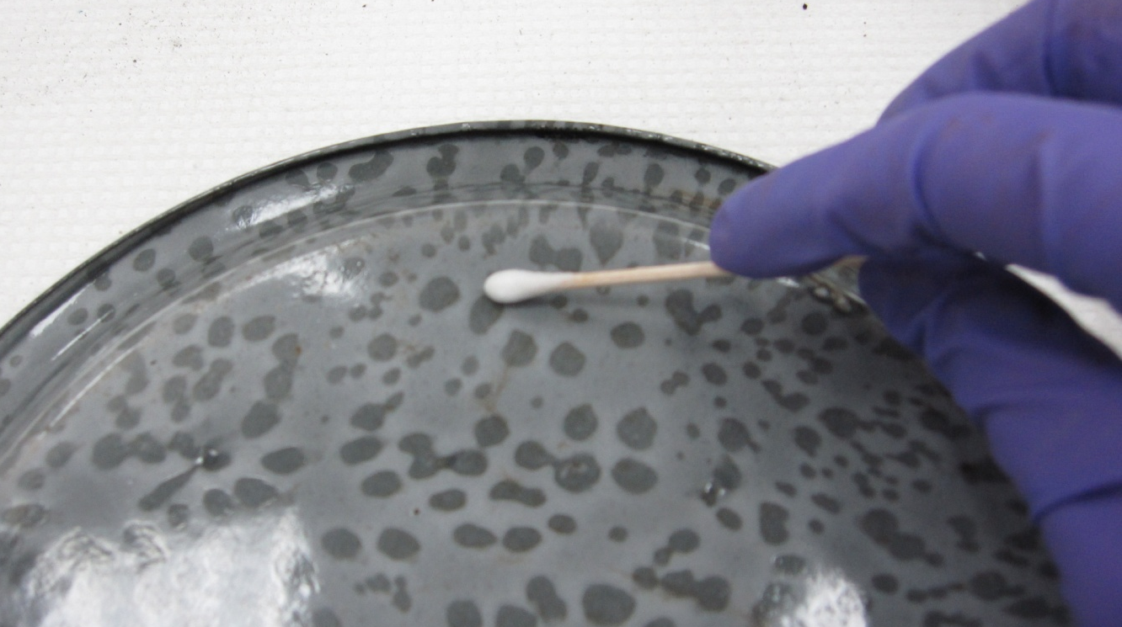
- Determine where you will be applying the label. It should be in an inconspicuous spot, usually on the reverse side or bottom of the object. For objects made of more than one material, choose the least porous surface (e.g. metal, shell, glass or ceramic are better than wood or leather) to attach the label. Avoid areas with paint or pigments. Ensure that the area where you will be applying the accession number is clean and dry. Gently remove dust from the surface, using either a clean soft brush or cotton swab.

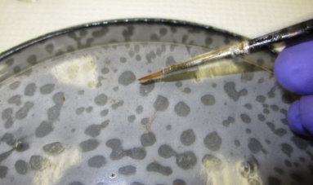
- Using a small paintbrush, apply a single coat of a mixture of 25% Paraloid® B-72 (Rohm & Haas, Philadelphia, PA) in acetone to the surface of the object, just larger than the size of the label. Be sure to work in a well-ventilated space.

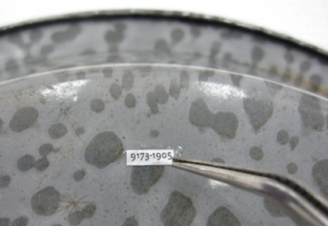
- Holding the label with tweezers, apply a thin coat of B-72 to the back of the label, and set it on the B-72 on the surface of the object. If the surface of the object is curved, or the label wants to curl up, hold the ends of the label down with the tweezers or wooden skewers until the B-72 has dried.

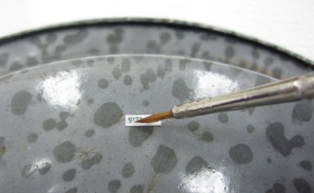
- Apply another thin layer of B-72 over the top of the label.

New Label, printed on buffered paper: Small, clear, neat, and safe for object’s surface.
Old Label, written in pen over barrier layer: Large, unclear, and unsightly with the potential for scratching surface of object.

